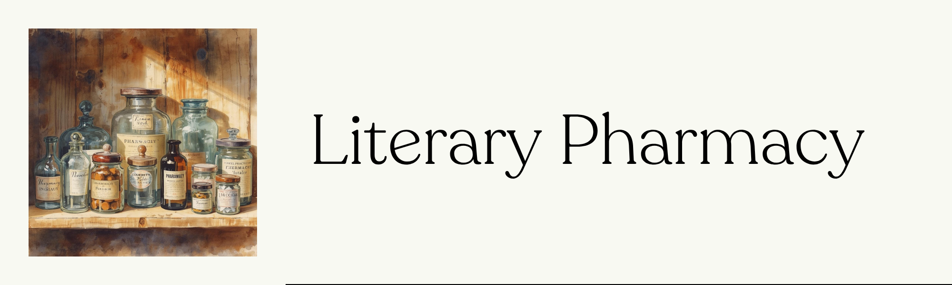

Chemist
Name of the medicine

Pharmacological category
Therapeutic indications
Dosage and administration
Side effects
Interactions


